School Management and Information System

Software Requirement Specification (SRS)

MASHAL UNIVSERSITY

Year: 2021

By: Tamana Shah

PART ONE:

**Requirement Gathering:**

The main purpose of this MIS is to pave the ground for the school users Students, Teachers and admin to process, manage and access to the system data.

As the MIS procedure will be as the Admin as a root user will have all the privileges to register students, teacher and manage information and data to the system.

The management of the data for students and teachers that will be providing the (The class grades, time tables, scores, subjects, exams, lessons progressing booklet management, attendance and much more to make the system for easy use and access to information as easy as possible for the users.

The system can be convoy with user creation mechanism and as well as with login page to get access to the specific data of the user.

The latter mechanism would be as security of the system as a main point for the safe usage of the data by the school users (Students, Admin and teachers).

The procedure that is going to be clarified in the following is showing the enhancement of the items that is needful for the School Management and Information System.

All the parts which is needed in the MIS is clarified in the following explanation of the system to be developed for the uses of the end users and stakeholders of school.

**ADMIN PANEL:**

1. What is the procedure of new comer student to register in school?
   * + - Tazkira
       - Health Form
       - Being 6 years old
       - Uniform for school
2. What factors are asked from students to get register in school system?

* Smartness
* Hand writing method
* Art if knows and asking his/ her fame
* Address

1. what documents school provide for a registered student?

* In order to make the students eligible at school:
* There is need of the documents for his/ her identity.
* A document for all the records

1. What is (3 parrcha documentation) process?

* Getting the approval of new school
* 3 Photos
* Tazkera
* A Copy of the student bio

1. What are the subjects’ lists for all class grades?

**Grade One, Two and Three:**

* Quran Kareem
* Islamic
* Dari
* Adaab
* Math
* Sport
* Art
* Tahzeeb

**Grade Four, Five and Six:**

* Quran Kareem
* Islamic
* Dari
* English
* Social studies
* Pashto
* Adaab
* Math
* Science
* Sport
* Art
* Tahzeeb

Grade Seventh, Eight and Ninth:

* Quran Kareem
* Islamic
* Dari
* English
* Social studies
* Pashto
* Adaab
* Math
* Science
* Arabic
* Sport
* Chemistry
* Geography
* Biology
* Physics
* History
* Profession
* WatanDosti
* Art
* Tahzeeb

Grade tenth, Eleventh and Twelfth:

* Quran Kareem
* Islamic
* Dari
* English
* Social studies
* Pashto
* Adaab
* Math
* Science
* Arabic
* Sport
* Chemistery
* Geography
* Biology
* Physics
* History
* Profession
* WatanDosti
* Quran Tafseer
* Geology
* Computer
* Business
* Culture
* Idealogy
* Civil
* Art
* Tahzeeb

1. **Application Create Account:**

**1- Admin Portal:**

The users account will be activate and assign by the admin of the system.

Admin have the full privilege for the assign the accounts and elements to the users (Students and Teachers).

The admin portal or panel is will appear to the user after successful logon which in this panel admin can access to the school management and information system which this part is called as Dashboard too.

This dashboard for the admin will consist of the different features and functionalities that would be useful for management of the system.

The admin panel will show the photo for the logout button from the system as the general functionalities of the admin portal system.

In order to assign and give privileges to an admin to manage the database and the system the admin can be assign for this kind of the management directly from the database backend.

The fields that are used to create a table for the collection of data about one admin can be as below

- User **admin** to register in the system the inputs are needed as below:

* admin id
* admin name
* password
* admin tazkera
* admin email address
* admin photo
* admin contact number

In the admin panel the user can login and access to the system with username “admin” and the set Password already set “admin” in the system table.

Admin panel features are as below:

1.1 Home page

1.2 Add Student

1.3 Add Teacher

1.4 View Scores

1.5 View attendance

1.6 User Details as profile

**1.1 Home Page:** This part of the dashboard is for displaying all page links that is belong to the admin dashboard and the user can navigate to any page related to this part of the project.

Navigation in this part is mainly on below pages:

1.1 Home page

1.2 Add Student

1.3 Add Teacher

1.4 View Scores

1.5 View attendance

1.6 User Details as profile

**1.2 Add Student:** In this part admin can enroll and register student to the school management system. Also the admin has the privileges of any changes in the records of the student if necessary.

By clicking over the link of Add Student the user will redirect to add student page which this page contain a form with required fields to be filled and submit to the database.

The web form will be containing below fields:

* Name (Label and Text field is needed for this field)
* Father Name (Label and Text field is needed for this field)
* Sir Name (Label and Text field is needed for this field)
* Password (Label and text field is needed for this field)
* Tazkera ID (Label and Text field is needed for this field)
* Age (Combo box will be used for this field)
* Date of Birth Contact Nr (Label and Text field is needed for this field)
* Address Contact Nr (Label and Text field is needed for this field)
* Contact Nr (Label and Text field is needed for this field)
* Student Photo (Image box will be used for this field)
* Class Grade (Combo box will be used for this field)
* **Transferee (Yes or No)** (Combo box will be used for this field if the Answer be NO the another fields will be disable)
* New
* Transfer
* A button will be used to submit the filled data of the form the database of the system.

The structure and format of the section also will have user photo and logout button.

**1.2 Add Teacher:** In this part admin can register teacher to the school management system. Also the admin has the privileges of any changes in the records of the teacher if necessary.

By clicking over the link of Add Teacher the user will redirect to add student page which this page contain a form with required fields to be filled and submit to the database.

The web form will be containing below fields:

* Name (Label and Text field is needed for this field)
* Father Name (Label and Text field is needed for this field)
* Sir Name (Label and Text field is needed for this field)
* Password (Label and Text field is needed for this field)
* Tazkera ID (Label and Text field is needed for this field)
* Age (Combo box will be used for this field)
* Date of Birth Contact Nr (Label and Text field is needed for this field)
* Home address (Label and Text field is needed for this field)
* Contact Nr (Label and Text field is needed for this field)
* Teacher Photo (Image box will be used for this field)
* Qualification (Combo box will be used in this field to show the list of the qualification of teachers Bachelor, Master, PhD, Diploma)
* Field (Combo box will be used to show the list of the fields teacher has qualification)
* A button will be used to submit the filled data of the form the database of the system.

The structure and format of the section also will have user photo and logout button.

In order to get access to the account to interact with the system data and information each stakeholders/ users need to create account in the system.

To create account each users need to complete data in different fields.

* User for students
* User for teachers

- User **students** to register in the system the inputs are needed as below:

* Name
* Father Name
* Sir Name
* Password
* Tazkera ID
* Age
* Date of Birth
* Contact Nr
* Home Address
* Contact Nr
* Student Photo
* Class Grade
* **Transferee (Yes or No)**
* New
* Transfer

- User **teacher** to register in the system the inputs are needed as below:

* Name
* Father Name
* Sir Name
* Password
* Tazkera ID
* Age
* Date of Birth
* Contact Nr
* Home address
* Contact Nr
* Teacher Photo
* Qualification

1. **Main Login form in the application for authorization:**

Being registered in the system you can login in the system as Student, Teacher and Admin which each stakeholder can get interact with the system and access to data and information.

The “Login System” is essential mechanism to this application as Students, Teachers and Admin can access to the specific data and information as they required need to get login as per their already provided information as:

* Username
* Password

**2.1-** Username

The username field forms from parts for students would show enrolled name in the system.

**2.2-** Password:

The password field provide the passing character to the system along the id field.

If the user (Student/ Teacher/ Admin) input their correct (ID and Password) would be lead to the assigned dashboard for access to the system information.

In case the user input is incorrect he/ she would be rejected to get to the dashboard which this occur in some reasons which can be not registered with the system.

**2.3-** Options (**Student** – **Teacher** – **Admin**):

The user can select one provided options in the page to introduce him or herself to the system as they are student, teacher or admin which want to access to the system.

Ignoring to select any of the options the system cannot grant to access to dashboard even though user input correct id and password information. As this options are the part of essential information to this login page.

**2.4-** Login Button:

Inputting the ID and Password to the field’s users can use login button to implement the login command privilege their access to the system which this can be done through the login button of the page.

Getting access to the system users features will be as following:

* **The student user can access to information and can interact with below functionalities of the MIS.**
  + 1. Attendance
    2. Exam Results
    3. Subjects
    4. Home works
    5. User details as profile
* **The teacher user can access to information and can interact with below functionalities of the MIS.**
  + 1. Attendance
    2. Exam
    3. Subjects
    4. Marks
    5. Lessons Progress
    6. Home works
    7. User details as profile
* **The admin user can access to information and can interact with below functionalities of the MIS.**
  + 1. View of Attendance for students
    2. View of Exam Results
    3. Students Register
    4. Teachers Register
    5. User details as profile

Following a successful logon to the system all the users will face with a designed Dashboard that facilitate all the information about related field.

If he or she is student, teacher or admin then can access to the specific data for belonging field in the panels.

**3-**Student Portal:

The student portal or panel is will appear to the user after successful logon which in this panel students can access to the school management and information system which this part is called as Dashboard too.

This dashboard will consist of the different features and functionalities

* 1. Attendance
  2. Exam
  3. Exam Results
  4. Subjects
  5. Home works
  6. Chapter and books
  7. **Attendance**: This feature would conduct information about students’ presence, absentee, sickness, leave and complete result of the student attendance during the educational term to the school.
     1. By clicking this part in the dashboard the user will get another page with attendance content result from the daily status of the attendance of the students.

This content result will be displayed in table which specific fields of the attendance as below:

* Student ID
* Name
* F/Name
* Date
* Class Grade
* Status of the timesheet as (Present, absent, sickness)

Also this section of attendance page will has Result Label that is about the result reporting of the students as can attend the Exam Or that is Restricted from attending to the exam?

This procedure will be processed after typing the student ID and Name in the text fields that is provided in this attendance page.

A button for performance of this mentioned functionality is provided as well to the page.

* 1. **Exam** (Score ) **results**: This part will notify the students about the exam results which will consist of the different parts:

Gaining of scores at each subjects in different exams of the educational term.

Notification of the pass or fail status of the exam to students

Instruction of the students in case of fail to how to recover the subject passing for the next (available) exam.

* + 1. This part will show a page with content about the exam. The page content will be read by a table which the table fields to be as follow:
* Exam type (Midterm, final and quiz)
* Score

At the bottom of the page will be show the summarization of the data collected from the table in this part.

* 1. **Subjects**: This part will provide information about the subjects which are assigned to specific class and grade for students.
     1. This part will has a table with specific fields and data:

1. Subject
2. Class Grade
3. Educational Year
4. Teacher Name

By this table user will access to data about the subjects that studies in school during one year of educational.

* 1. **Homework**: This part will show all the list of the Home Works which are assigned to the students and will consist of the status notification if the students submit the homework or not or its still pending which would be essential in score notes of each subject.

Each subject will include of main homework part which will be display in this section.

* + 1. This part will has a table with specific fields and data about:
* Subject
* Title
* Content
* Issue Date
* Deadline
* Class
* Teacher

The student dashboard will have the button for Logout which this function uses for session abandon of the user that can be claim as a security full of the MIS

**4-**Teacher Portal:

The teacher portal or panel is will appear to the user after successful logon which in this panel teachers can access to the school management and information system which this part is called as Dashboard too.

The teacher portal structure will be as to show the user photo, logout function button the segments to connect us to a specific webpages of the information and data.

This dashboard will consist of the different features and functionalities

* 1. Attendance
  2. Marks
  3. Lessons Progress Booklet
  4. Create Homework
  5. Home works
  6. Timetable
  7. **Attendance**: This feature would conduct information about teachers’ presence, absentee, sickness, leave and complete result of the student attendance during the educational term to the school.

This part will collect information about the teacher attendance which would will include a part of the report create options which will cover the salary parts from this section for each teacher and calculate the salary payment of the month.

* + 1. This section of the portal is the attendance for the teachers which provide facility of access of the teachers to get the report about the monthly attendance in school.

This section would consist of the below fields to get the data from database

* ID
* Name
* F/Name
* Date
* Class Grade
* Attendance status

The structure and format of the section also will have user photo and logout button.

The data which will display in this part will be derived from database and all the fields would have specific labels for this display purpose for the user.

* 1. **Create Exam Score:** This part is provided the marks to students by the teacher on the subjects that he or she implement in the class. This marks will be for the exams, quizzes, and homework and class activities and students attendances of everyday.

This part will include student:

* Mark
* Student ID
* Subject list
* Teacher name
* Class grade
* Type of the exam
  + 1. This part will be for insertion of the students’ exam details and scoring in midterm and final exam. The teacher user can insert the details of the student gotten by the conducted exams and the students paper results are fed to the system in this part.

This section would have the objects which will facilitate the insertion operation to the system:

* Label and text box for the ID field
* Label and text box for the student name field
* Combo box which will maintained the name of the subjects from the database
* Label and text field for the subject Score
* Label and text field Class activation of score for the student
* Label and text field Exam type (Midterm or final exam)
* SUBMIT BUTTON for doing the insertion operation of the above mentioned fields.

The structure and format of the section also will have user photo and logout button.

* 1. **Lessons Progress Booklet/Outline note:** This part will be used as online notation part by the teacher user to input the daily lessons implementation progress and the subjects which is implemented on the classes.
     1. This part will provide a form for insertion operation of the lessons which conducts daily by a teacher user:

This part will be including different fields to complete this purpose in the system database.

There will be:

* ID label and text field for the teacher user ID
* Label and text field for the teacher Name.
* Label and text field for the subject
* Label and text field for the title of the lesson
* Label and text area field for the lesson(s) content
* Label and text field for the class grade
* Label and text field of the present students number
* Label and text field for the date
* Label and text field for the time
* Submit button to deliver the form filled content to the system.

The structure and format of the section also will have user photo and logout button.

* 1. **Homework**: This part will give the teacher the ability to issue the homework for the subjects which teaches in school.
     1. This part will provide a form for insertion operation of the Home Work which conducts daily by a teacher user, if any.

This part will be including different fields to complete this purpose in the system database.

There will be:

* ID label and text field for the teacher user ID
* Label and text field for the teacher Name.
* Label and text field for the subject
* Label and text field for the title of the lesson
* Label and text area field for the lesson(s) content as HOME WORK
* Label and text field for the class grade
* Label and text field for the date
* Label and text field for the HOME WORK Deadline
* Submit button to deliver the form filled content to the system.

The structure and format of the section also will have user photo and logout button.

PART 2:

**Requirement Analysis and Designing:**

2.1 SYSTEM ARCHTICTURAL DESIGN:

As the product is school MIS the software maintains and record all the data from the students, teacher and admin that creates on their dashboards.

Basic interface through which the user will interact with the system are the different screens with multiple items having the facility of manipulation as adding, searching, updating of the records with different aspects. The system will be efficient and compatible with other system working in the environment.

**SYSTEM DESIGN:**

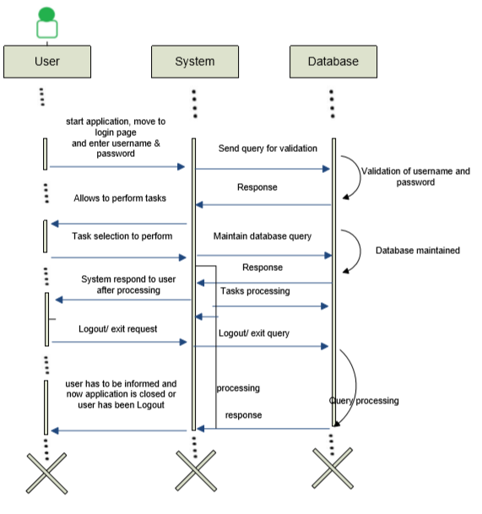

**SYSTEM FLOWCHART**

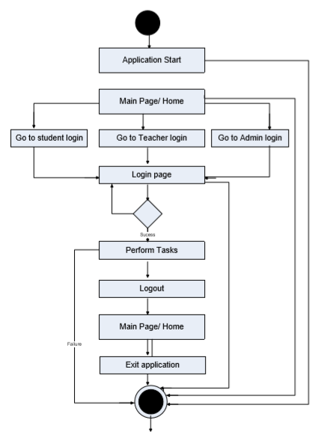

**DFD LEVEL NOT (0):**

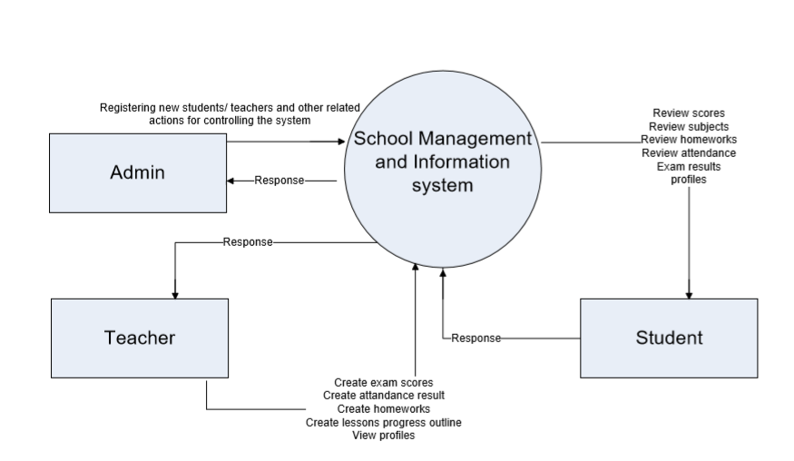

**Class Diagrams:**

Please see the attachments.

**DATABASE TABLES RELATIONSHIPS DIAGRAMS**

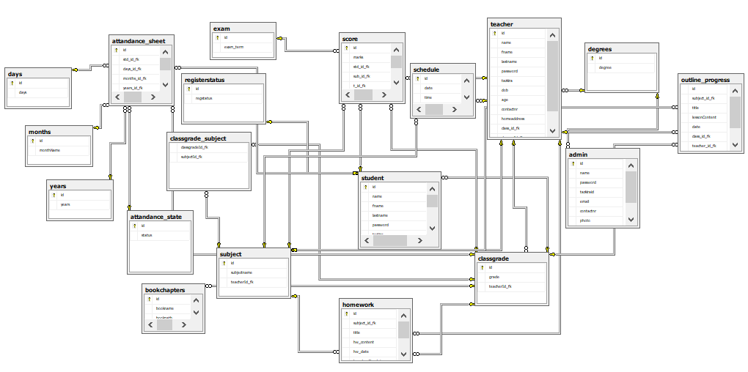



**Database (Tables and Views) and Data Design:**

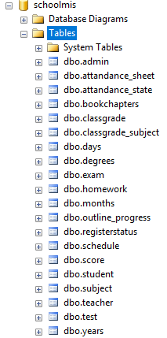

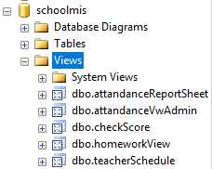

**Database Tables Descriptions:**

1-admin_Table

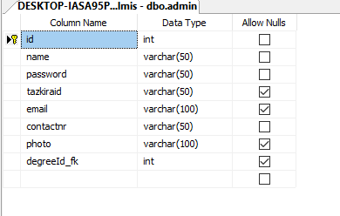

2-attandance_sheet

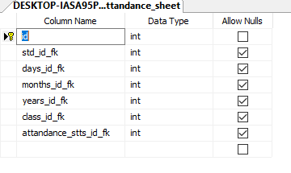

3-attandance_state

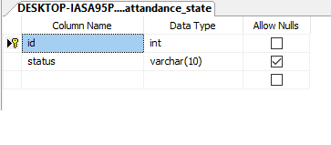

4-bookchapters

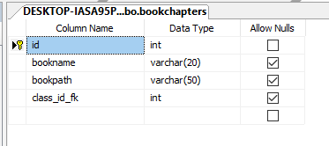

5-classgrade

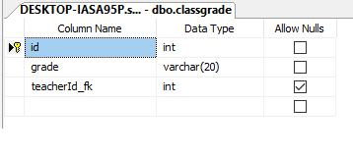

6-classgrade_subject

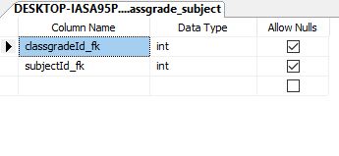

7-days

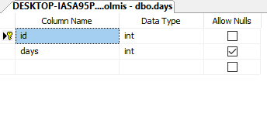

8-degrees

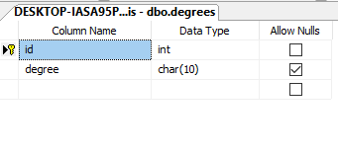

9-exam

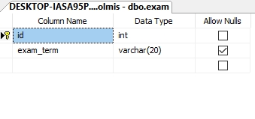

10-homework

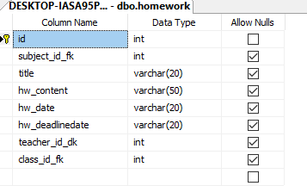

11-months

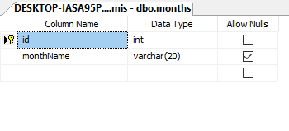

12-outline_progress

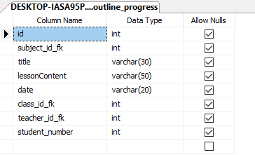

13- registerstatus

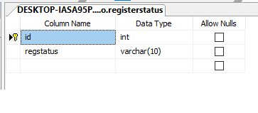

14-schedule

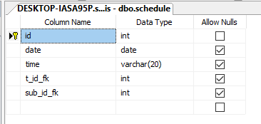

15- score

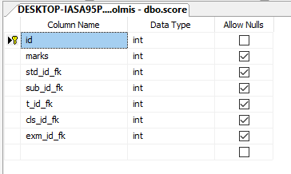

16- student

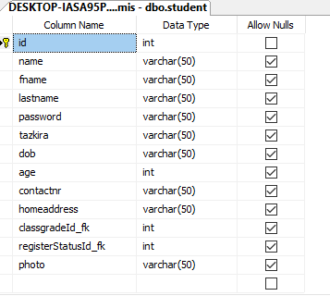

17-subject

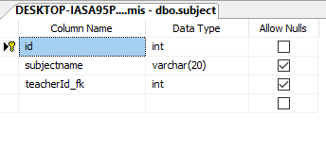

18-teacher

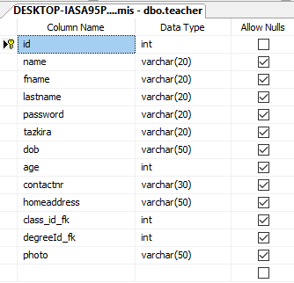

19-years

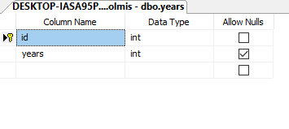

PART 3:

**USER INTERFACE (UI) DESIGN**

**3.1 - STUDENT PORTAL**

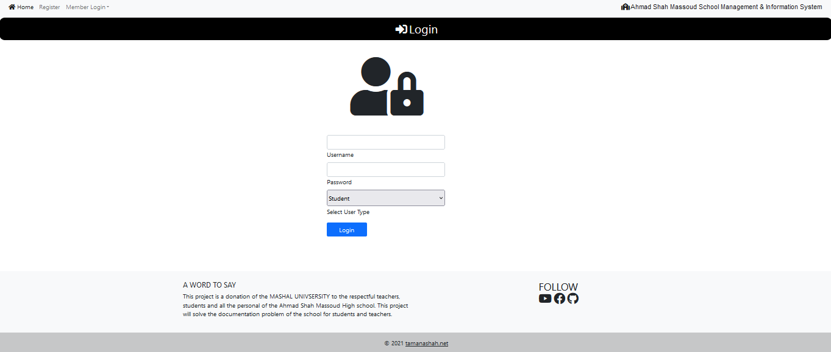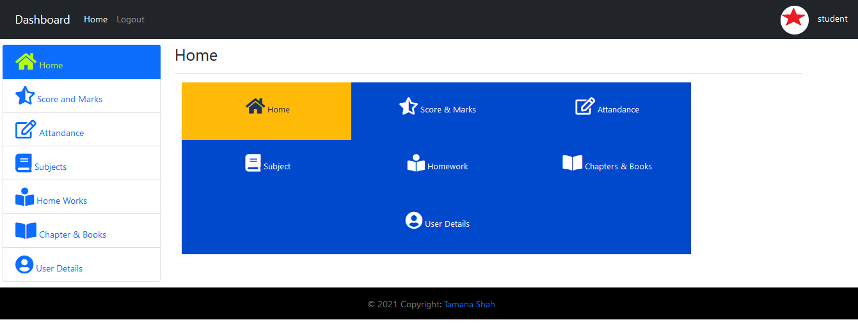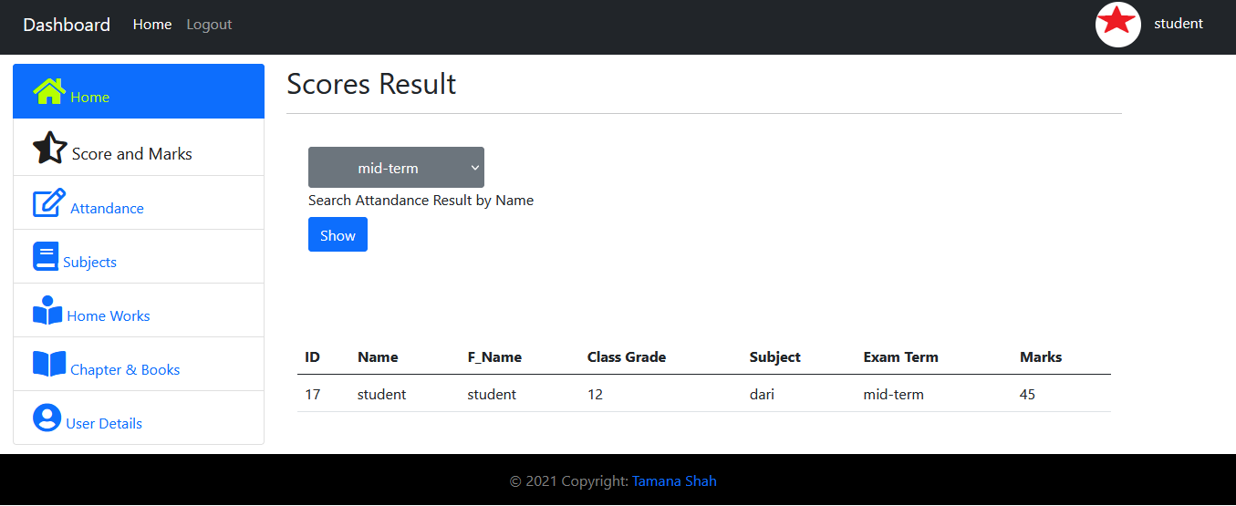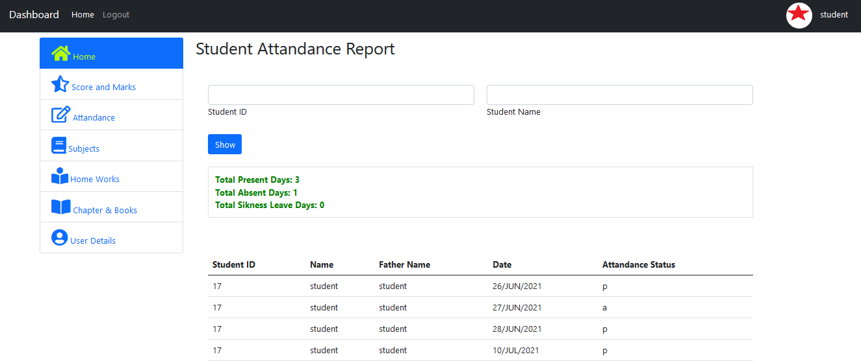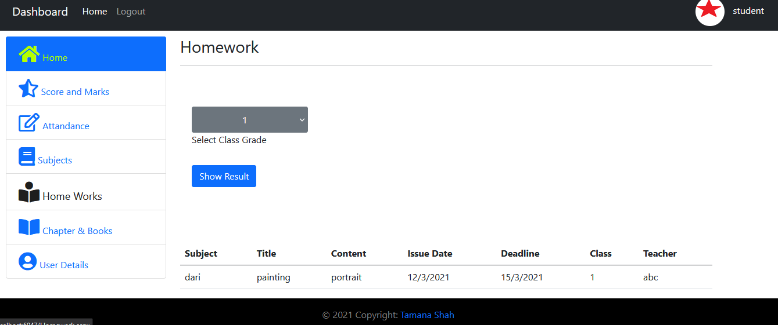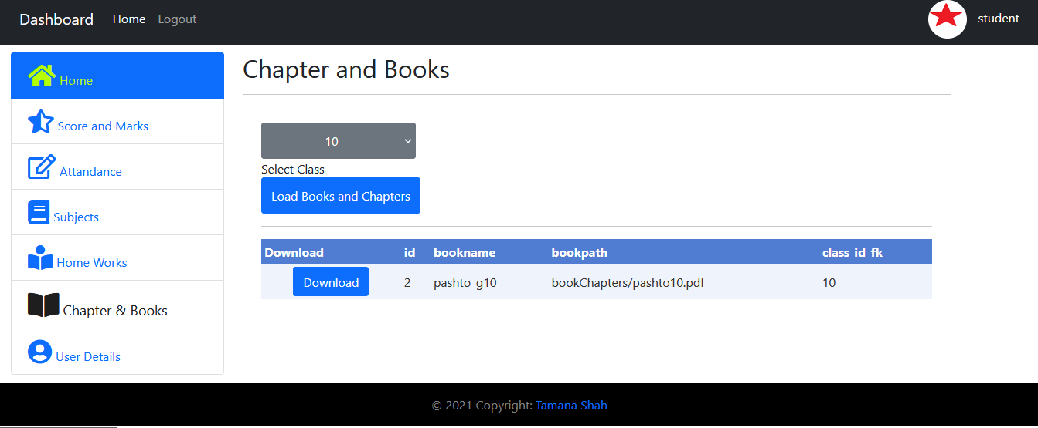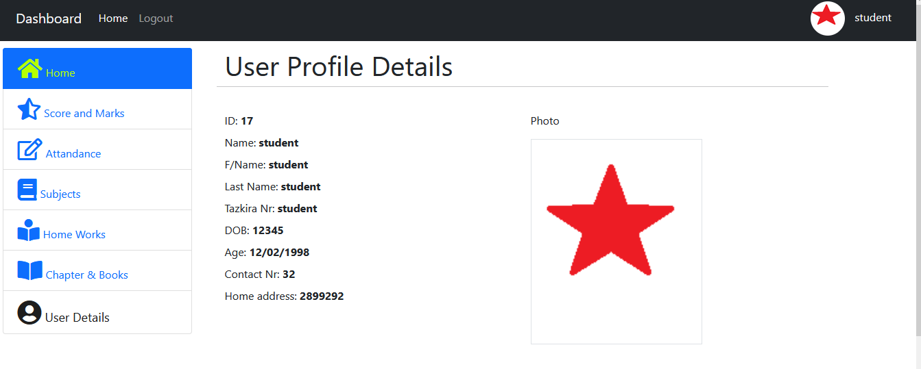

**3.2 - TEACHER PORTAL**

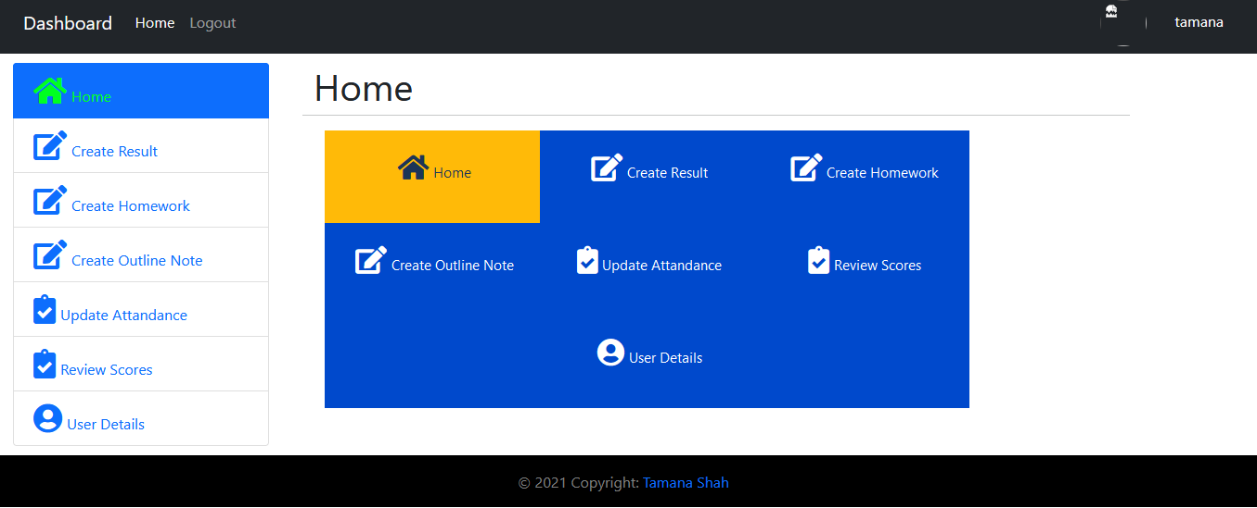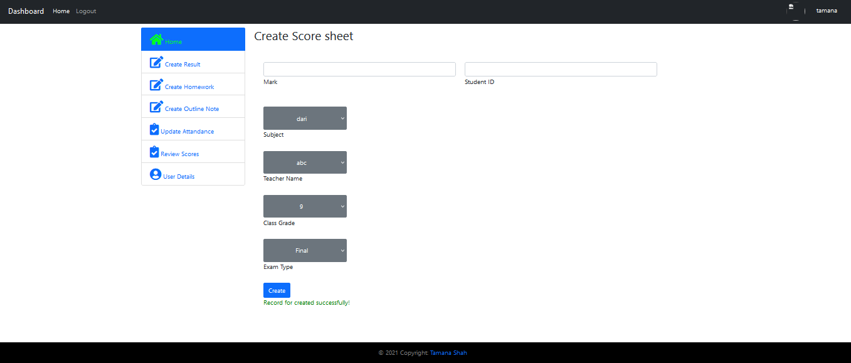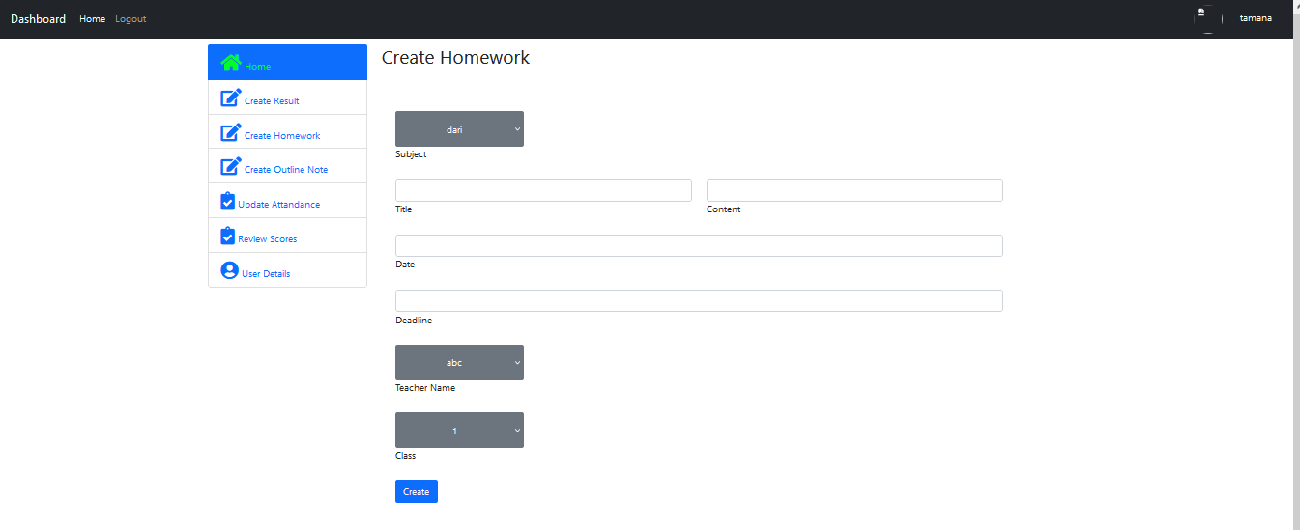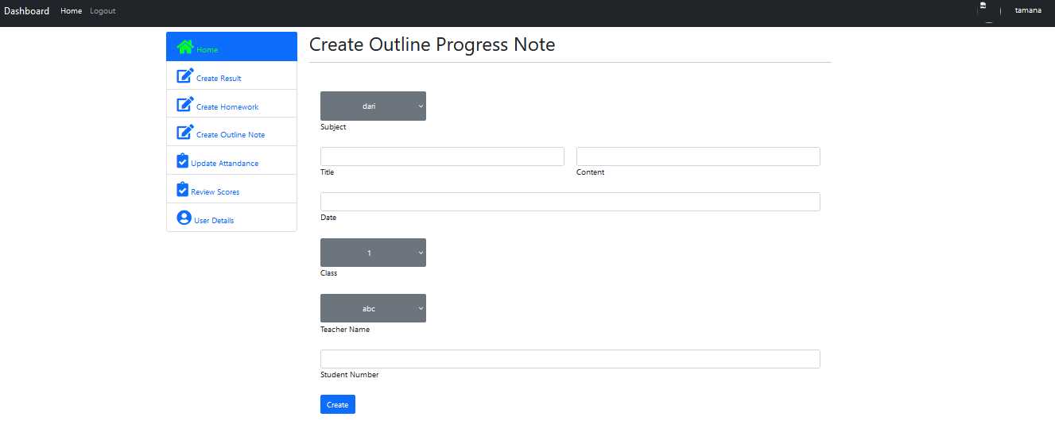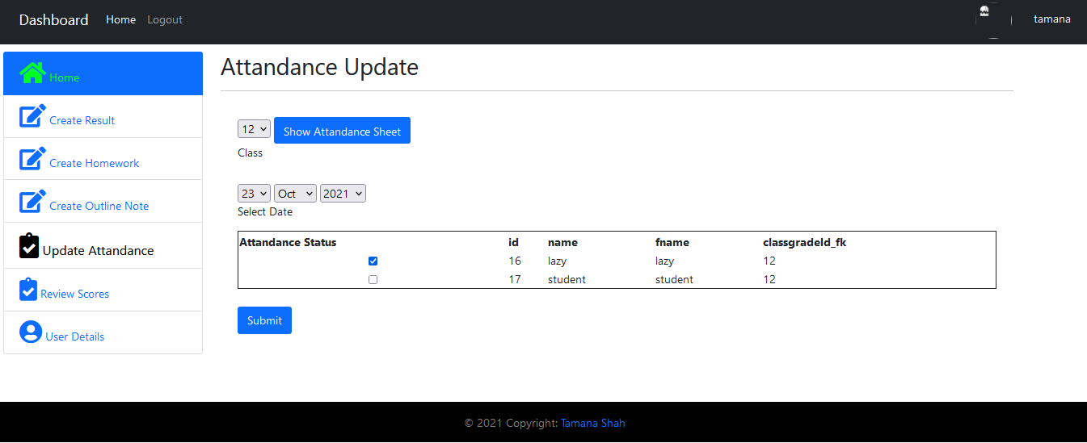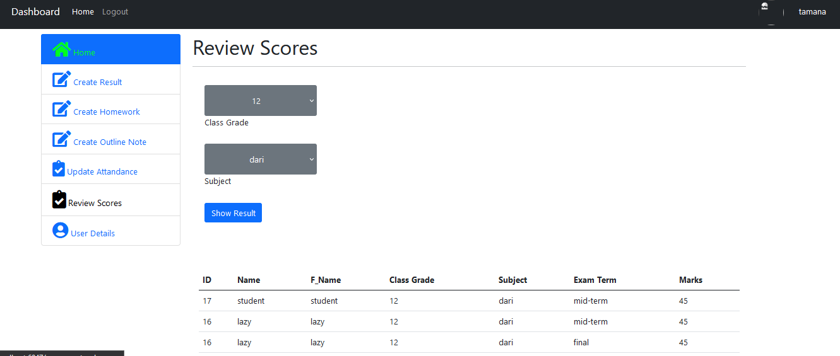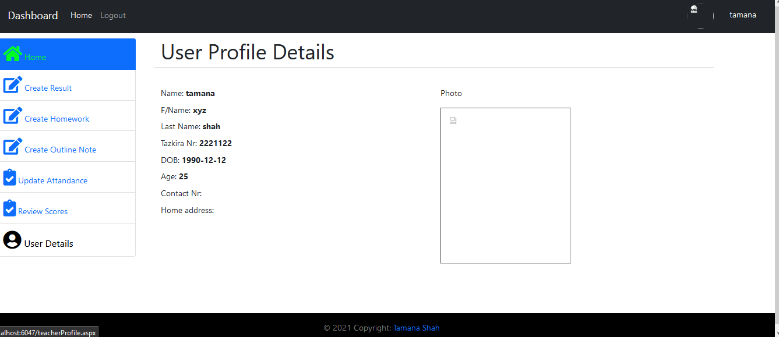

**3.3- ADMIN PORTAL**

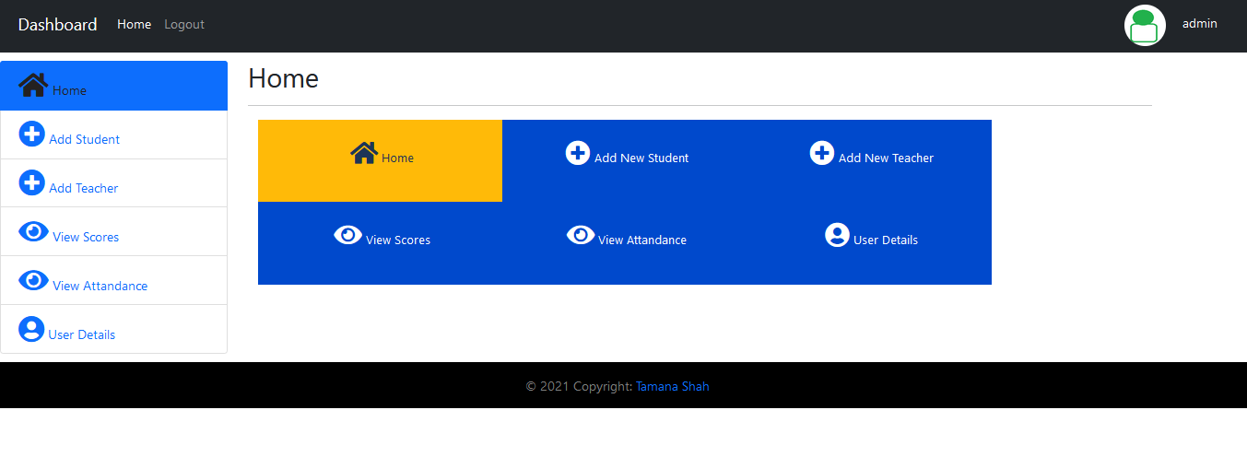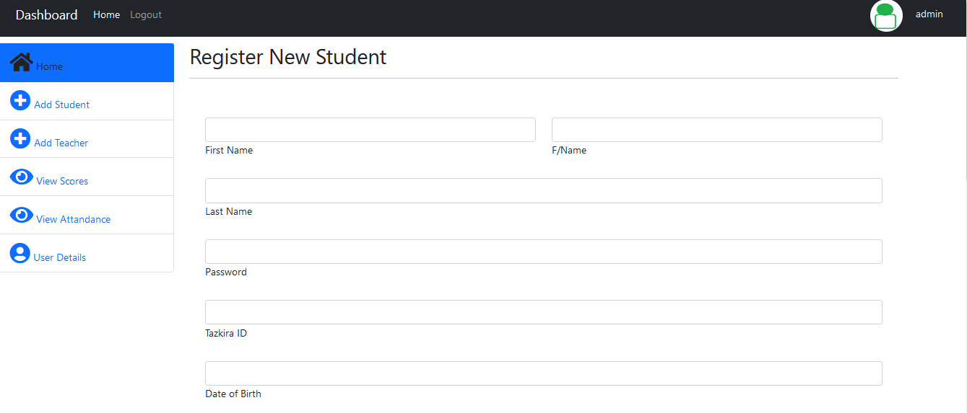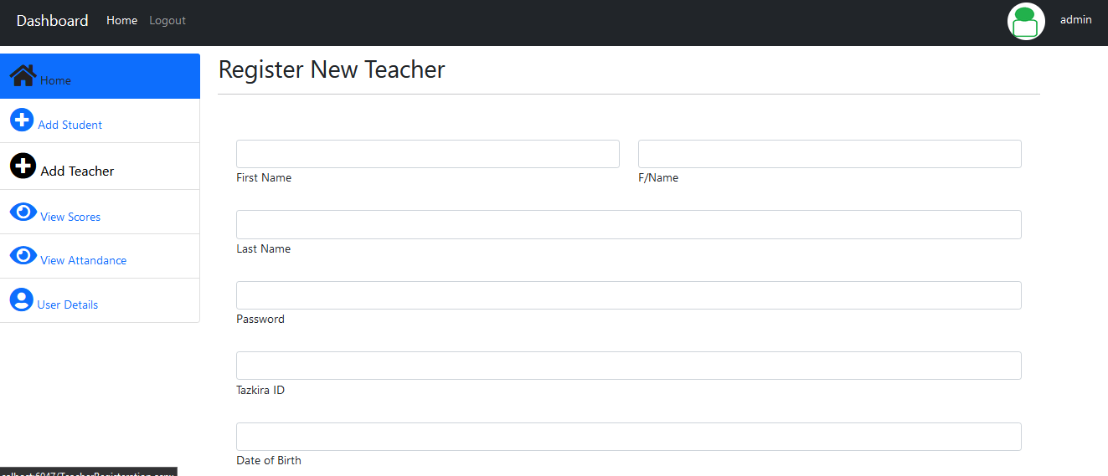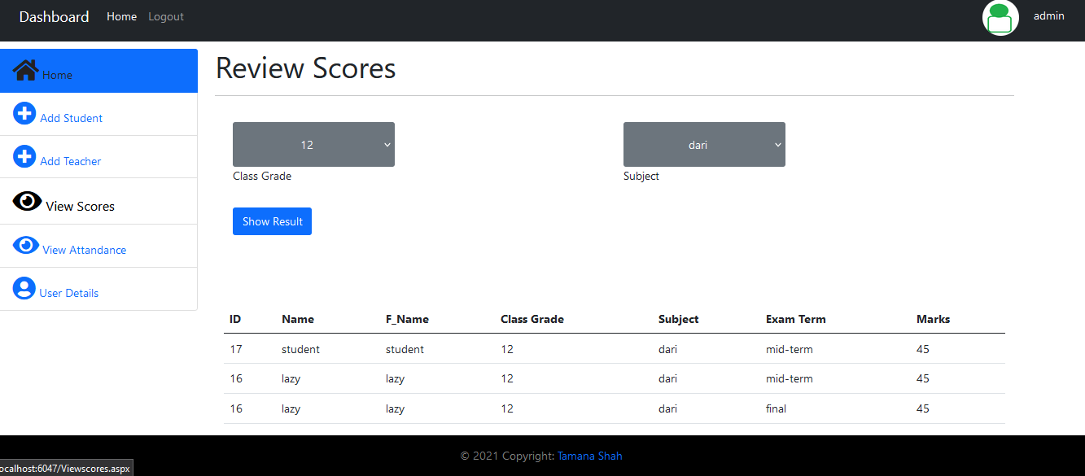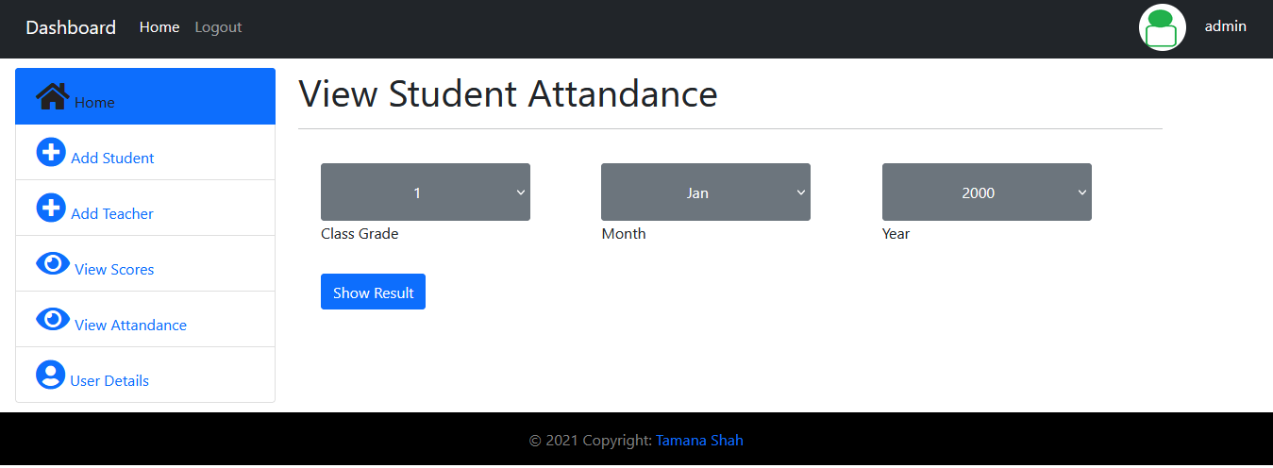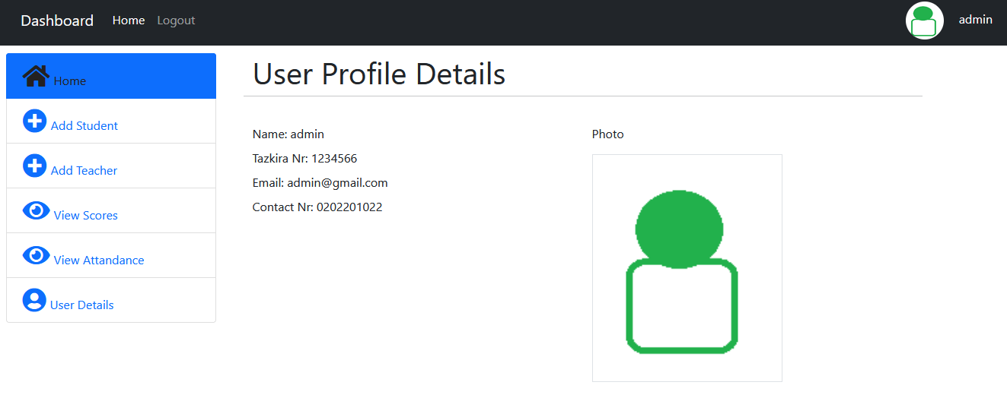

**3.4 – HOME/ REGISTERATION PROCESS INFO PAGES**

